Tsai, No 10220513

Specification and operation manual of WK 1J1022, for liquid dielectric test

Manual of Liquid Fixture 1022

1J1022 Operation Manual

Table of contents

Wayne Kerr Electronics Liquid dielectric test operation manual 2

1 Background 2

2 Definition of dielectric 2

3 Dielectric constant measured by parallel plate method 3

4 Composition of 1J1022 5

5 Combination of 1J1002+1J1022 6

6 Specification 6

7 Calibration process 7

8 WK 6500B Relative dielectric constant testing software 7

9 WKE Liquid Test liquid dielectric constant 10

10 Precautions 10

11 Related formulas 11

12 Part number 11

## Wayne Kerr Electronics Liquid dielectric test operation manual

### 1 Background

When applying an electric field to Dielectric material will produce a surface charge to weaken the electric field. The ratio of the electric field in the original media applied electric field (vacuum) and the electric field in the final dielectric media will be the dielectric constant. The most commonly used dielectric material is an insulator such as ceramic, mica, glass, plastic, organic material, etc., but some liquid may also be used as a good dielectric material .

The dielectric’s permittivity of microwave chemistry, geophysics, remote sensing environmental monitoring, and food safety is of great significance. By calculating gasoline dielectric constant, we can determine the quality of gasoline. In the basement of the oilfield detection, the dielectric constant can be used to differentiate between hydrocarbon-bearing layers and aquifers. Further experiments show that changes in the dielectric constant are related with the mileage, lubricating oil acid value and iron content. So that we can use dielectric constant to evaluate the performance of the engine oil. In food safety, the dielectric constant can be used to determine the change in cooking oil heated to high temperatures or prolonged storage variations in quality.

### 2 Definition of dielectric

Dielectric constant describes the interaction between the material and the electric field. Figure 1 showing the primary dielectric constant calculation formula. Dielectric constant(K) equal to complex relative dielectric constant $\left({εr}^{*}\right)$ or the ratio of the complex dielectric constant $\left(ε^{*}\right)$ and the vacuum dielectric constant $\left(ε0\right)$. The real part of the complex relative dielectric constant $\left({εr}^{’}\right)$ represents the number of energy storage in the material at external electric field. For most solids and liquids, ${εr}^{’}$ > 1. The imaginary parts of the complex relative dielectric constant $\left({εr}^{’’}\right)$ is called dissipation factor (D). It indicates that the material stored electrical energy consumed or how much is lost to the external electric field, $\left({εr}^{’’}\right)$ always > 0,dissipation factor includes a dielectric material loss and conductivity effects.

If we use a simple vector (Fig 1) represents the complex dielectric constant. Then the phase of the real and imaginary parts will differ by 90°. Its vector and the real axis (${εr}^{’}$) form an angle δ. Usually we use this tangent of that angle (tan δ) or tangent of dissipation angle to indicate the relative "loss" of the material. The term "loss" in the technical literature, is also known as "dielectric loss."

|  |  |
| --- | --- |
| Fig. 1 Definition of relative complex dielectric constant | $$K^{*}=ε_{r}^{*}=\frac{ε^{*}}{ε_{0}}=ε_{r}^{'}-jε_{r}^{''}=\left(\frac{ε^{'}}{ε_{0}}\right)-j\left(\frac{ε^{''}}{ε_{0}}\right)$$ $tanδ=\frac{ε_{r}^{''}}{ε_{r}^{'}}$ =D  D: Dissipation factor $K^{*}$ : dielectric constant $ε_{0}$ : dielectric constant of free space |

### 3 Dielectric constant measured by parallel plate method

When using an impedance analyzer to measure the dielectric constant, we usually use the parallel plate method. Parallel plate method in the ASTM D150 standard, is also known as 3-terminal method. The principle is to insert a liquid material or a sheet between two electrodes to form a capacitor. (Note: In the following section, we will use MUT represent for the testing materials no matter them are solid or liquid.) Then measure the capacitance, calculated dielectric constant based on the measurement results.

|  |
| --- |
| Fig. 2 Schematic diagram of liquid fixture 1J1022 |

In Fig. 2, the Ground electrode can eliminate measurement errors caused by fringe capacitance, protective electrode absorb electrical field at the edge. Therefore, the capacitance we measure from the electrode is only from by the current flowing through the dielectric material. So that it can obtain accurate measurement results. When using a combination of the main electrode and the guard electrode, the main electrode is called guard electrode.

### 4 Composition of 1J1022

1J1022 shown below:

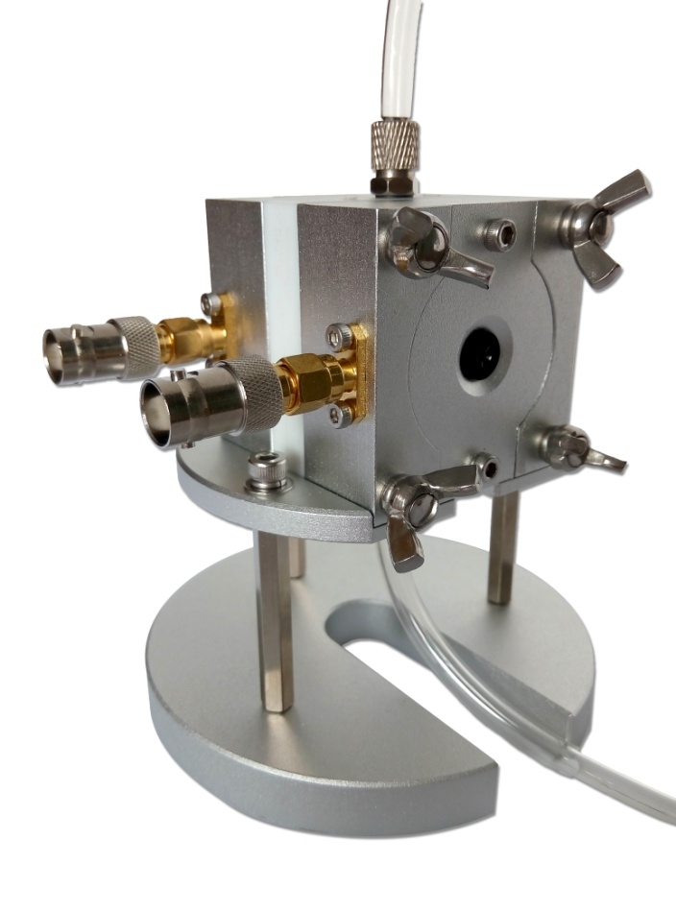

Composition of 1J1022:

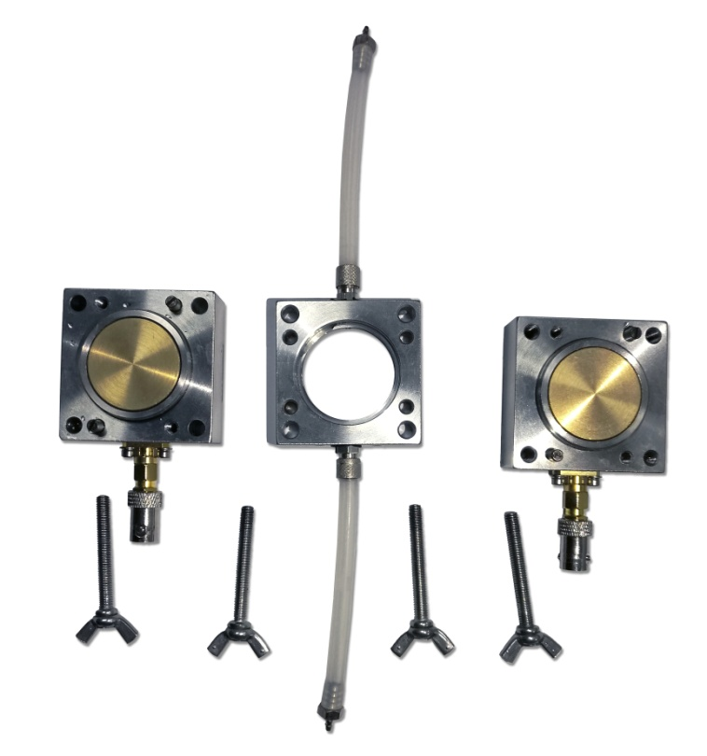

5

4

3

2

1

|  |  |  |
| --- | --- | --- |
| index | item | description |
| 1 | Upper electrode | Diameter 26mm |
| 2 | Liquid containing chamber | Diameter 32mm Thickness 2mm |
| 3 | Liquid conduit | Diameter 6mm |
| 4 | Lower electrode | Diameter 30mm |
| 5 | Screw | 4 x claw style screws |

Note: A minimum of injection liquid volume: 3ml, liquid jig load capacitance 1.3pF ± 10%

### 5 Combination of 1J1002+1J1022

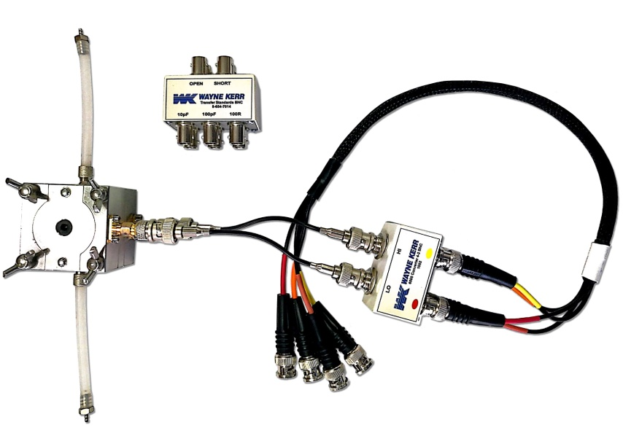

1J1002 is the 4 to 2 BNC convertor used to connect to WK instrument. We can calibrate the 1J1002 cable with high-frequency calibrator, and then connect to the fixture for measurement. To increase the accuracy of the test, open and short calibration can be done at both ends of the liquid fixture.

### 6 Specification

* Test frequency range: 20Hz~30MHz
* Basic measurement accuracy: 0.05%（6500）
* Minimum of injection liquid volume: 3ml
* Operating temperature: -25℃~125℃
* Calibration compensation: Open / Short / High frequency compensation

### 7 Calibration process

* Connect 1002, set the calibration frequency at 30MHz
* Open trim, short trim, high-frequency calibration for 1J1002’s connection cable
* Connect 1J1022, then do the open trim, short trim, calibration



### 8 WK 6500B Relative dielectric constant testing software

|  |
| --- |
| Wayne Kerr 6500B precision impedance analyzer software has optional materials testing software (ordering code: /K). This software can only be installed on a precision impedance analyzer; it cannot be installed on a 6500P high-frequency LCR meter. With this software, you can calculate the relevant parameters of relative dielectric constant more easily. The software interface is as follows:  CEZoom6  Dielectric constant test parameters: $E_{r}^{*}$ Complex Relative dielectric constant values $E_{r}^{'}$ The real part of Relative dielectric constant $E''r$ The imaginary part of Relative dielectric constant $tan δ$ Dissipation factor  D Dissipation factor |
| CEZoom4  Materials Testing Setup:   1. Non-Contact Method：Choose this option 2. Electrode separation ‘tg’: 2.1mm 3. Material thickness ‘tm’：1.5mm 4. Close liquid fixture 1J1022, leave it empty then press Measure Cg reference data, wait until test finish. 5. Add the test liquid, choose test parameter: 6. Press Trigger to test |

### 9 WKE Liquid Test liquid dielectric constant

This software can test the dielectric constant changes with frequency and time. The scanning time can be set to a plurality of frequencies to be tested.

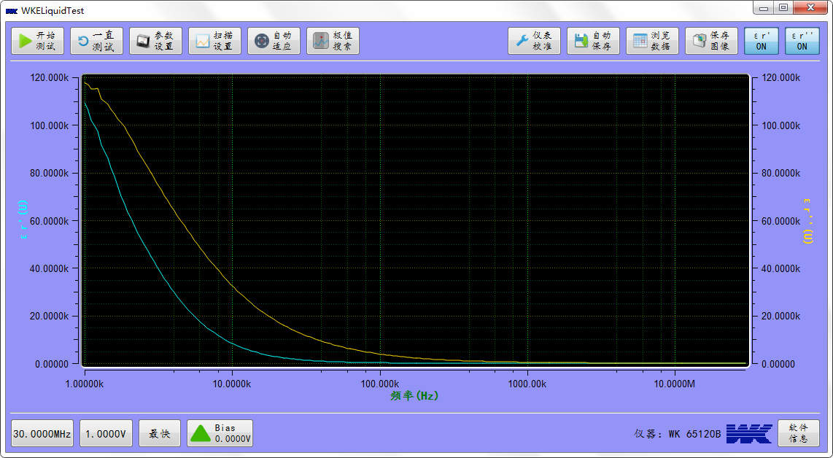

**Dielectric constant sweep frequency test**

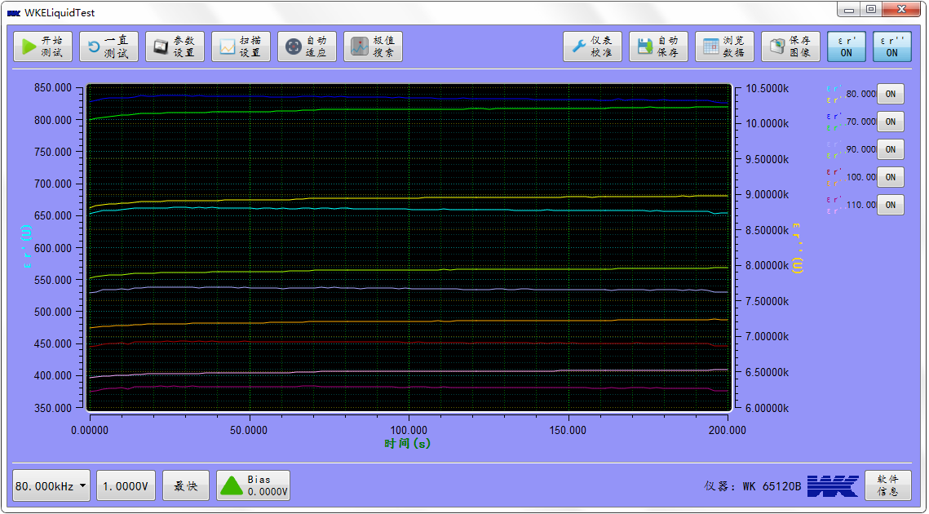

**Dielectric constant time changes scanning**

**Test procedure**

1. Set up the frequency range and points
2. Select the C0 tested in the settings, and select the equivalent circuit in parallel, please do not put in any liquid
3. Make a test of the C0 value then save the file
4. Pour in the liquid, choose $E_{r}^{'}$ $E''r$
5. Make the test via pressing the test button

### 10 Precautions

1. 1022 calibration: After complete testing of high concentration of ions or conductive ability of the liquid, you need to clean and dry the 1022 and do the calibration again. To prevent the ions attach on the electrodes affect the calibration.
2. 1022 test the Co value: After complete testing of high concentration of ions liquid, you must clean and dry the 1022 before making the test of Co value again. Do not just dry the 1022 then test the Co value. Because the electrodes will attach a certain amount of conductive ions, make the error of testing the Co value.
3. In the calibration or test with the Co, please make level with the two hose on the 1022, and not place it vertically. To prevent the liquid flow to the two electrodes of the capacitor chamber, and make error with the Co calibration or test result.
4. After complete testing of corrosive liquids; make sure the jig is proper washed to prevent corrosion.

### 11 Related formulas

When testing the dielectric constant, we have done a test of air capacitor C0. Through the instrument test the Cp-Rp, and then use the formula to calculate dielectric constant.

The equivalent circuit model for understanding the liquid:

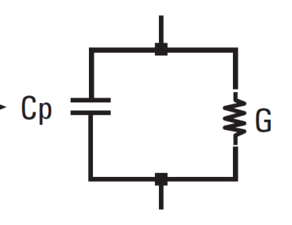

The formula of the dielectric constant of the equivalent circuit:

$$ε_{r}^{'}=\frac{C_{p}}{C_{0}}$$

$$ε_{r}^{''}=\frac{1}{ωC_{0}R_{p}}$$

### 12 Part number

|  |  |
| --- | --- |
| **Equipment** | **Part Number** |
| 4 to 2 connection adaptor (20Hz ~ 120MHz) | 1J1002 |
| Liquid fixture | 1J1022 |
| Liquid fixture connection test software | WKE Liquid Test |
| WK6500B Materials testing software | /K |